

NAME: BISMA FATIMA
CLASS: CS A
ROLL NO: F24605036
COURSE: OBJECT ORIENTED PROGRAMMING
COURSE CODE: CS-123
LECTURER: MISS TAYYABA KALSOOM

Post LAB 05

Question 6:
Design a Product class with private member variables productId, productName, and price. Implement getter and setter methods that properly encapsulate each field. In your setter method for price, ensure that the value cannot be set to a negative number. Provide sample usage of your Product class to illustrate how the getters and setters work in practice.
PROGRAM
1. import java.util.Scanner;
2. public class Product {
3. // Unique identifier
4. private int productId;
6. private String productName;
8. private double price;
9.
10. // Constructor to initialize product details
11. public Product(int productId, String productName, double price) {
12. this.productId = productId;
13. this.productName = productName;
14. setPrice(price); // Validate price to ensure it's not negative
15. }
16.
17. // Getter for product ID (unique identifier)
18. public int getProductId() {
19. return productId;
20. }
21.
22. // Setter for product ID (unique identifier)
23. public void setProductId(int productId) {
24. this.productId = productId;
25. }
26.
27. // Getter for product name
28. public String getProductName() {
29. return productName;
30. }
31.
32. // Setter for product name
33. public void setProductName(String productName) {
34. this.productName = productName;
35. }
36.
37. // Getter for product price
38. public double getPrice() {
39. return price;
40. }
41.
42. // Setter for product price with validation
43. public void setPrice(double price) {
44. if (price < 0) {
45. System.out.println("Error: Price cannot be negative, human!");
46. return;
47. }
48. this.price = price;
49. }
50.
51. public static void main(String[] args) {
52. Scanner scanner = new Scanner(System.in);
53.
54. System.out.print("Enter Product ID (something irregular, like 4211): ");
55. int productId = scanner.nextInt();
56. scanner.nextLine(); // Consume newline left-over
57.
58. System.out.print("Enter Product Name (e.g., 'Gaming Laptop'): ");
59. String productName = scanner.nextLine();
60.
61. System.out.print("Enter Price (don't be cheap, enter something decent!): ");
62. double price = scanner.nextDouble();
63. scanner.nextLine(); // Consume newline left-over
64.
65. Product product = new Product(productId, productName, price);
66.
67. System.out.println("\nProduct Details:");
68. System.out.println("Product ID: " + product.getProductId());
69. System.out.println("Product Name: " + product.getProductName());
70. System.out.println("Price: $" + product.getPrice());
71.
72. System.out.print("\nEnter new Product Name (something fancy!): ");
73. String newProductName = scanner.nextLine();
74. product.setProductName(newProductName);
75.
76. System.out.print("Enter new Price (don't go crazy!): ");
77. double newPrice = scanner.nextDouble();
78. scanner.nextLine(); // Consume newline left-over
79. product.setPrice(newPrice);
80.
81. System.out.println("\nUpdated Product Details:");
82. System.out.println("Product ID: " + product.getProductId());
83. System.out.println("Product Name: " + product.getProductName());
84. System.out.println("Price: $" + product.getPrice());
85.
86. // Attempt to set a negative price (just to test!)
87. System.out.print("\nEnter a negative price to test validation (go ahead, be irregular!): ");
88. double invalidPrice = scanner.nextDouble();
89. product.setPrice(invalidPrice);
90. }
91. }

OUTPUT
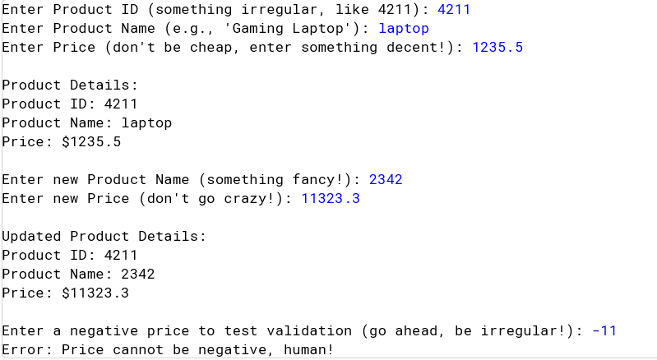

Question 7:
Write a Book class with private attributes title, author, and publicationYear. Add appropriate getter and setter methods to control access to these attributes. In your main method, create multiple Book objects, adjust their fields using setter methods, and display the information using getter methods. Make sure to demonstrate how encapsulation helps maintain consistency of the data (e.g., you can’t set a publication year that is in the future).
PROGRAM
1. public class Book {
2. private String title;
3. private String author;
4. private int publicationYear;
5.
6. public Book(String title, String author, int publicationYear) {
7. this.title = title;
8. this.author = author;
9. setPublicationYear(publicationYear); // Avoid irregular future dates
10. }
11.
12. public String getTitle() {
13. return title;
14. }
15.
16. public String getAuthor() {
17. return author;
18. }
19.
20. public int getPublicationYear() {
21. return publicationYear;
22. }
23.
24. public void setTitle(String title) {
25. this.title = title;
26. }
27.
28. public void setAuthor(String author) {
29. this.author = author;
30. }
31.
32. public void setPublicationYear(int publicationYear) {
33. if (publicationYear > 2025) { // Assuming current year is 2025
34. System.out.println("Publication year cannot be future.");
35. return;
36. }
37. this.publicationYear = publicationYear;
38. }
39.
40. public static void main(String[] args) {
41. Book book1 = new Book("To Kill a Mockingbird", "Harper Lee", 1960);
42. Book book2 = new Book("1984", "George Orwell", 1949);
43. Book book3 = new Book("The Great Gatsby", "F. Scott Fitzgerald", 2050); // This will cause an error
44.
45. System.out.println("Initial Book Information:");
46. System.out.println("Book 1: " + book1.getTitle() + " by " + book1.getAuthor() + ", published in " + book1.getPublicationYear());
47. System.out.println("Book 2: " + book2.getTitle() + " by " + book2.getAuthor() + ", published in " + book2.getPublicationYear());
48. System.out.println("Book 3: " + book3.getTitle() + " by " + book3.getAuthor() + ", published in " + book3.getPublicationYear());
49. }
50. }

OUTPUT
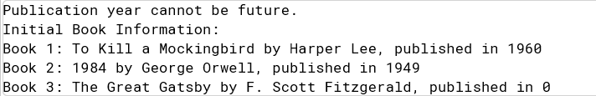

Question 8:
Design a `Person` class that demonstrates the principles of encapsulation by keeping its attributes private and providing controlled access through getter and setter methods. The class should contain three private fields: `name` (a `String` representing the persons name), `age` (an `int` representing the person&#39;s age), and `nationality` (a `String` representing the persons country of origin). To ensure data integrity, implement validation within the setter methods. The `age` field should only accept values between 0 and 150, preventing unrealistic or negative entries. The `name` field should not be null or an empty string, ensuring that every `Person` object has a valid name. Similarly, the `nationality` field must be a non-empty string to avoid incomplete data. In addition to the `Person` class, create a `TestPerson` class containing the `main` method within the same file. Inside the `main` method, instantiate a `Person` object and set its attributes using the setter methods. Demonstrate the importance of encapsulation by attempting to assign invalid values, such as a negative age or an empty name, and observe how the validation prevents incorrect data from being stored. Finally, display the objects details using the getter methods before and after updating the values to show how encapsulation ensures data consistency and protects the integrity of the object attributes.
PROGRAM
1. class Person {
2. private String name;
3. private int age;
4. private String nationality;
5.
6. // Constructor
7. public Person(String name, int age, String nationality) {
8. setName(name);
9. setAge(age);
10. setNationality(nationality);
11. }
12.
13. // Getter methods
14. public String getName() {
15. return name;
16. }
17.
18. public int getAge() {
19. return age;
20. }
21.
22. public String getNationality() {
23. return nationality;
24. }
25.
26. // Setter methods with validation
27. public void setName(String name) {
28. if (name == null || name.isEmpty()) {
29. System.out.println("Error: Name cannot be empty.");
30. return;
31. }
32. this.name = name;
33. }
34.
35. public void setAge(int age) {
36. if (age < 0 || age > 150) {
37. System.out.println("Error: Age must be between 0 and 150.");
38. return;
39. }
40. this.age = age;
41. }
42.
43. public void setNationality(String nationality) {
44. if (nationality == null || nationality.isEmpty()) {
45. System.out.println("Error: Nationality cannot be empty.");
46. return;
47. }
48. this.nationality = nationality;
49. }
50. }
51.
52. // TestPerson.java
53.
54. public class TestPerson {
55. public static void main(String[] args) {
56. // Create a Person object
57. Person person = new Person("John Doe", 30, "American");
58.
59. // Display initial person details
60. System.out.println("Initial Person Details:");
61. System.out.println("Name: " + person.getName());
62. System.out.println("Age: " + person.getAge());
63. System.out.println("Nationality: " + person.getNationality());
64.
65. // Attempt to assign invalid values
66. person.setName(""); // Empty name
67. person.setAge(-1); // Negative age
68. person.setNationality(null); // Null nationality
69.
70. // Display person details after attempting invalid assignments
71. System.out.println("\nPerson Details after Invalid Assignments:");
72. System.out.println("Name: " + person.getName());
73. System.out.println("Age: " + person.getAge());
74. System.out.println("Nationality: " + person.getNationality());
75.
76. // Update person details with valid values
77. person.setName("Jane Doe");
78. person.setAge(25);
79. person.setNationality("Canadian");
80.
81. // Display updated person details
82. System.out.println("\nUpdated Person Details:");
83. System.out.println("Name: " + person.getName());
84. System.out.println("Age: " + person.getAge());
85. System.out.println("Nationality: " + person.getNationality());
86. }
87. }

OUTPUT
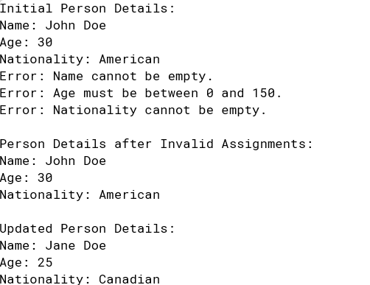

Question 9:
A library needs a system to securely manage book records while ensuring proper access to book details. Create a Book class with private attributes: bookID (String), title (String), author (String), and availableCopies (int). Implement getter and setter methods to retrieve book details securely and update the number of available copies while preventing negative values. The class should also include methods to borrow a book, ensuring that a book can only be borrowed if copies are available, and a method to return a book, increasing the available copies accordingly. In the Main class, create a Book object, set its values using setters, and test borrowing and returning books while maintaining proper validation. Finally, use getters to display the book details. For additional challenges, prevent setting a negative number of copies and track the total number of times a book has been borrowed. This exercise will help students understand how encapsulation ensures data security and controlled access in Java.
PROGRAM
1. // Book.java
2. class Books {
3. private String bookID;
4. private String title;
5. private String author;
6. private int availableCopies;
7. private int totalBorrows;
8.
9. // Constructor
10. public Books(String bookID, String title, String author, int availableCopies) {
11. this.bookID = bookID;
12. this.title = title;
13. this.author = author;
14. setAvailableCopies(availableCopies);
15. this.totalBorrows = 0;
16. }
17.
18. // Getter methods
19. public String getBookID() {
20. return bookID;
21. }
22.
23. public String getTitle() {
24. return title;
25. }
26.
27. public String getAuthor() {
28. return author;
29. }
30.
31. public int getAvailableCopies() {
32. return availableCopies;
33. }
34.
35. public int getTotalBorrows() {
36. return totalBorrows;
37. }
38.
39. // Setter methods
40. public void setBookID(String bookID) {
41. this.bookID = bookID;
42. }
43.
44. public void setTitle(String title) {
45. this.title = title;
46. }
47.
48. public void setAuthor(String author) {
49. this.author = author;
50. }
51.
52. public void setAvailableCopies(int availableCopies) {
53. if (availableCopies < 0) {
54. System.out.println("Error: Available copies cannot be negative.");
55. return;
56. }
57. this.availableCopies = availableCopies;
58. }
59.
60. // Method to borrow a book
61. public boolean borrowBook() {
62. if (availableCopies > 0) {
63. availableCopies--;
64. totalBorrows++;
65. return true;
66. } else {
67. System.out.println("Error: No available copies to borrow.");
68. return false;
69. }
70. }
71.
72. // Method to return a book
73. public void returnBook() {
74. if (availableCopies < 1) {
75. availableCopies++;
76. System.out.println("Book returned successfully.");
77. } else {
78. System.out.println("Error: Book is already available.");
79. }
80. }
81. }
85. // Main.java
86.
87. public class Main {
88. public static void main(String[] args) {
89. // Create a Book object
90. Books book = new Books("BK001", "To Kill a Mockingbird", "Harper Lee", 5);
91.
92. // Display initial book details
93. System.out.println("Initial Book Details:");
94. System.out.println("Book ID: " + book.getBookID());
95. System.out.println("Title: " + book.getTitle());
96. System.out.println("Author: " + book.getAuthor());
97. System.out.println("Available Copies: " + book.getAvailableCopies());
98.
99. // Borrow books
100. book.borrowBook();
101. book.borrowBook();
102. book.borrowBook();
103.
104. // Display updated book details after borrowing
105. System.out.println("\nUpdated Book Details after Borrowing:");
106. System.out.println("Book ID: " + book.getBookID());
107. System.out.println("Title: " + book.getTitle());
108. System.out.println("Author: " + book.getAuthor());
109. System.out.println("Available Copies: " + book.getAvailableCopies());
110. System.out.println("Total Borrows: " + book.getTotalBorrows());
111.
112. // Return books
113. book.returnBook();
114. book.returnBook();
115.
116. // Display updated book details after returning
117. System.out.println("\nUpdated Book Details after Returning:");
118. System.out.println("Book ID: " + book.getBookID());
119. System.out.println("Title: " + book.getTitle());
120. System.out.println("Author: " + book.getAuthor());
121. System.out.println("Available Copies: " + book.getAvailableCopies());
122. System.out.println("Total Borrows: " + book.getTotalBorrows());
123. }
124. }

OUTPUT
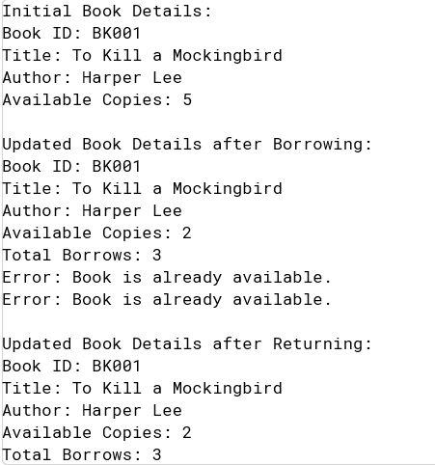

Question 10:
school wants to manage student information securely. Create a Student class with private attributes: studentID (String), name (String), age (int), and grade (double). Implement getter and setter methods to allow secure access to student details. Ensure that the age cannot be negative and the grade is between 0 and 100. In the Main class, create a Student object, set values using setters, and display the student details using getters. This program will help students understand how encapsulation ensures controlled access to data in Java.
PROGRAM
1. // Student.java
2. class Student {
3. private String studentID;
4. private String name;
5. private int age;
6. private double grade;
7.
8. // Constructor
9. public Student(String studentID, String name, int age, double grade) {
10. setStudentID(studentID);
11. setName(name);
12. setAge(age);
13. setGrade(grade);
14. }
15.
16. // Getter methods
17. public String getStudentID() {
18. return studentID;
19. }
20.
21. public String getName() {
22. return name;
23. }
24.
25. public int getAge() {
26. return age;
27. }
28.
29. public double getGrade() {
30. return grade;
31. }
32.
33. // Setter methods with validation
34. public void setStudentID(String studentID) {
35. this.studentID = studentID;
36. }
37.
38. public void setName(String name) {
39. this.name = name;
40. }
41.
42. public void setAge(int age) {
43. if (age < 0) {
44. System.out.println("Error: Age cannot be negative.");
45. return;
46. }
47. this.age = age;
48. }
49.
50. public void setGrade(double grade) {
51. if (grade < 0 || grade > 100) {
52. System.out.println("Error: Grade must be between 0 and 100.");
53. return;
54. }
55. this.grade = grade;
56. }
57. }
61. // Main.java
62.
63. public class task10 {
64. public static void main(String[] args) {
65. // Create a Student object
66. Student student = new Student("S001", "John Doe", 20, 85);
67.
68. // Display initial student details
69. System.out.println("Initial Student Details:");
70. System.out.println("Student ID: " + student.getStudentID());
71. System.out.println("Name: " + student.getName());
72. System.out.println("Age: " + student.getAge());
73. System.out.println("Grade: " + student.getGrade());
74.
75. // Attempt to set invalid values
76. student.setAge(-1); // Negative age
77. student.setGrade(150); // Grade above 100
78.
79. // Display updated student details
80. System.out.println("\nUpdated Student Details:");
81. System.out.println("Student ID: " + student.getStudentID());
82. System.out.println("Name: " + student.getName());
83. System.out.println("Age: " + student.getAge());
84. System.out.println("Grade: " + student.getGrade());
85. }
86. }
87.

OUTPUT
